AKPsi Better Together Resource Packet

Use with the AKPsi Better Together Checklist

INITIATING
Directions: Use these templates to guide your team through the INITIATE phase of the project.
Working Name for our AKPsi Better Together Project |  | Enter name here
 | Name |  | Email | Phone | Timezone
AKPsi Project Manager
Commonwealth Leadership® Alliance resource
Project Management Institute (PMI) resource

PLANNING
Directions: Use these templates to guide your team through the PLAN phase of the project.

Context
Partnering Student Organization |  |  | Enter name here
 | Name | Email |  | Phone | Timezone
Partnering Student Organization Point of Contact
Together, AKPsi/PMI/Partnering Organization, discover the opportunity or problem, and create the vision for your Better Together Initiative using the template below.

Discovery
AKPsi Leadership Methodology - Clarify
Using our AKPsi model, determine what information you need to clarify the project.
- Clarifying is an art – it means asking the right questions, listening, and be able to restate what you heard
- There are two main focal points to clarify:
  - Discovering opportunities
  - Outlining the problem
What has happened in the community?
What is the situation that you need to make a decision about?
What are you trying to solve?

Vision/Benefit/Impact Statement
Vision of the initiative – Write a clear statement describing the purpose of this initiative
Value – How will the community benefit from this initiative? What is compelling and exciting about it?
Member Benefit – What is in this for your members? How will this benefit them?
Impact Statement – Summarize your vision and value/benefits above | “The xxx community will be able to xxx so that xxx outcome is achieved, and team members will be able to practice xxx, so that they build their skills in xxx.”

PLANNING Context (Continued)
Scope
Participants – Who is specifically expected to attend the event?
Limit – How many can attend the event at one time?
Number – How many times will this event be run?
Constraint – Is there anything that should not be part of the event?

Project Charter
Team Members by Organization who will participate |  |  | Name |  |  |  |  | Email |  |  |  | Phone |  | Timezone
AKPsi
Partnering Student Organization (replace with the name of the organization)
Team Norms – ways we agree to work together (Add more rows if needed)
Norms may be around how the team will communicate, make decisions, resolve conflicts, etc.
Team Norm:
Team Norm:
Team Norm:
Team Norm:
Objectives for our Better Together Initiative
Make these SMART – specific, measurable, attainable, relevant, time-based
Add more rows as needed
Objective 1
Measurement – how we will know we have met this |  |  |  |  |  |  |  |  |  | Date to achieve this (objectives without target dates are merely dreams)
Objective 2
Measurement – how we will know we have met this |  |  |  |  |  |  |  |  |  | Date to achieve this (objectives without target dates are merely dreams)
Project Charter (Continued)
Critical Success Factors (CSF)
How will we know we have been successful?
CFS 1
CFS2
Assumptions for our Better Together Initiative
What are you assuming will be in place, available, agreed-to, etc.? How will you confirm these are true or not?
Assumption |  |  |  |  |  | True? |  |  | False? |  | Action Needed?
Risks for our Better Together Initiative
Is there anything that might cause our project to not be successful? (Miss our timeline or not be able to do something)
Risk |  |  |  |  |  |  | Mitigation Actions (things we can do to make this less of an impact)

Content
Information Gathering / Planning
AKPsi Leadership Methodology - Analyze
Using our AKPsi model, determine what information you can you gather and assess to help you make an informed decision about how to act. Asking questions isn’t about getting an answer, necessarily. It’s really about listening to what the answer is telling you.
AKPsi Leadership Methodology – Act
Act on what the information is telling you. What are you going to do once you have all the information?
Strategic Level
Information to gather at the strategic level to assist with your vision
What is the strategic information telling you?
What should we be doing for our overall Program?
Situational Level
Information to gather at the situational level to assist with project
What is the situational information telling you?
What should we be doing as activities in our project?
Specific Level
Information to gather at the specific level to assist with completing a task
What is the specific information telling you?
What should we be doing as specific tasks in our project?

PLANNING Content (Continued)
Work Breakdown Structure / Organizational Resources Needed
How might you create your work breakdown structure (WBS)?
Are there any resources that need to be aligned to make this work more successful?
It may be helpful to do this in an app that allows you to brainstorm all the tasks in each category that need to be done. Something like Mind Manager is recommended.
WBS  A WBS helps us know how the work to be done fits into categories (add more rows as needed) | Resources to Align  Training, processes, policies, rewards, etc.

Budget
To be added by Chapter
Example – Source: https://www.projectmanager.com/training/create-and-manage-project-budget

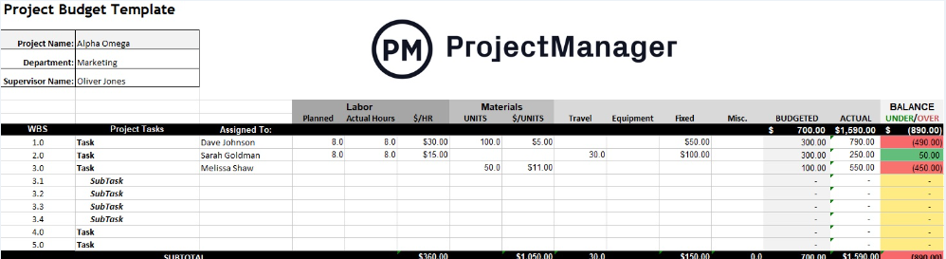

Staffing Plan
To be added by Chapter
Responsibility | Available Now? | Need to Procure?

Schedule
To be added by Chapter – answering the questions of who, does what, when, in which sequence
Example
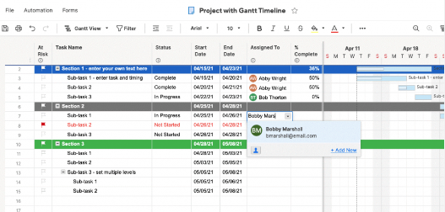

EXECUTING
Directions: Use these templates to guide your team through the ORGANIZE phase of the project.
Creating Understanding
How might you help your cross-chapter members of both organizations understand the plan?
Idea: Overview of the project?
Idea: Invitations?
Idea: Chapter meeting topics?
Idea: Event planning meetings?
What communication can you plan to engage your Community?
Idea: Personal presentations?
Idea: Invitations?
Idea: Advertising on Community channels?
Idea: Community meeting agendas?

Roles and Responsibilities / Skill Training
Which roles and responsibilities are of interest to the project participants? What are they passionate about learning?
Project Responsibility  Copy from Staffing Plan above | Name  Copy from Project Charter above | Passion  How might this help team members develop their “brand”?  How can this help team members develop their “super powers”? | Skills  Which skills might your cross-chapters team members need that they don’t already have to do these roles?

Cross-Team Development Plan
How can this project help team members advance their leadership practices, while enhancing the success of this project?
Team Member Development Resource | Link
Access the Commonwealth Leadership Alliance The JourneyTM and PMI courses to organize training resources. (Consider how these might apply to certificates or continuing education credits for your team members.) | To be added
Access the PMI courses to organize training resources. (Consider how these might apply to certification for your team members.) | To be added

MONITORING & CONTROL
Directions: Use these templates to guide your team through the CONTROL phase of the project.
Lessons Learned
What information are you learning as you manage the implementation of the initiative against the schedule?
What is the information telling you?
AKPsi Leadership Methodology – Act
As you make decisions, you need to then act with that decision in mind so you are modeling the agreed-to outcomes of the project.
Sometimes you may need to adjust your actions, so planning contingencies helps develop options for improvement.
Project Lesson Being Learned | Does this create an issue to be solved? Or is it improvement for next time? |  | Action to be Taken
 | - Issue for now | - Future improvement
 | - Issue for now | - Future improvement
 | - Issue for now | - Future improvement
 | - Issue for now | - Future improvement
Team Member Lesson Being Learned About Themselves! | Discovering Opportunities? |  | Seeing Unmet Needs?

MONITORING & CONTROL Communication (Continued)
Communication
How can you communicate to keep everyone understanding progress of the project?
Project Team Members
Ideas: Regularly scheduled team meeting report-outs (may be virtual), newsletters, Facebook postings, call tree for urgent needs
Cross-Team Project Team Member Name  Copy from Project Charter above | Telling Our Stories  When/where can each team member to tell their story of how they have grown?
Project Team Members
Ideas: Regularly scheduled team meeting report-outs (may be virtual), newsletters, Facebook postings, call tree for urgent needs
Write your Project Team Member communication strategies here:
- Xx
- Xx
- xx
Community Updates
How can we show the progress of how the vision that is taking shape and the value is being delivered?
Copy the vision from the Project Planning section: “The xxx community will be able to xxx so that xxx outcome is achieved, and team members will be able to practice xxx, so that they build their skills in xxx.”
Write your Community communication strategies here:
- Xx
- Xx
- xx

CLOSING
Directions: Use these templates to guide your team through the CLOSE phase of the project.
Post-Project Assessment
How can you help the team discover what has been learned during this project?
Project Team Members
When/where can each team member to tell their story of how they have grown?
Cross-Team Member’s Name  Copy from Project Charter | Tell Our Stories  When/where can each team member  tell their story of how they have grown? What is their Sweet Spot? (where their brand, super-powers, and unmet need all match up – so they are happy, effective, and paid!)
Project Objectives - copy from Project Charter in the PLAN Context section
Were the objectives of the project met? Were the critical success factors met?
Objective 1
Objective 2
Critical Success Factors (CSF) - copy from Project Charter in the PLAN Context section
How will we know we have been successful?
CFS 1
CFS2
Community
How can you hear from the community to find what went well, what can be improved?
Idea: Personal meeting with key community personnel
Idea: Survey of participants

Celebrate!
What ways will you celebrate success of the project with the cross-project team members?
Idea: Certificates
Idea: Party
Idea: Written Thank Yous
Idea: LinkedIn Recommendation

